Real Time implementation of Selenium
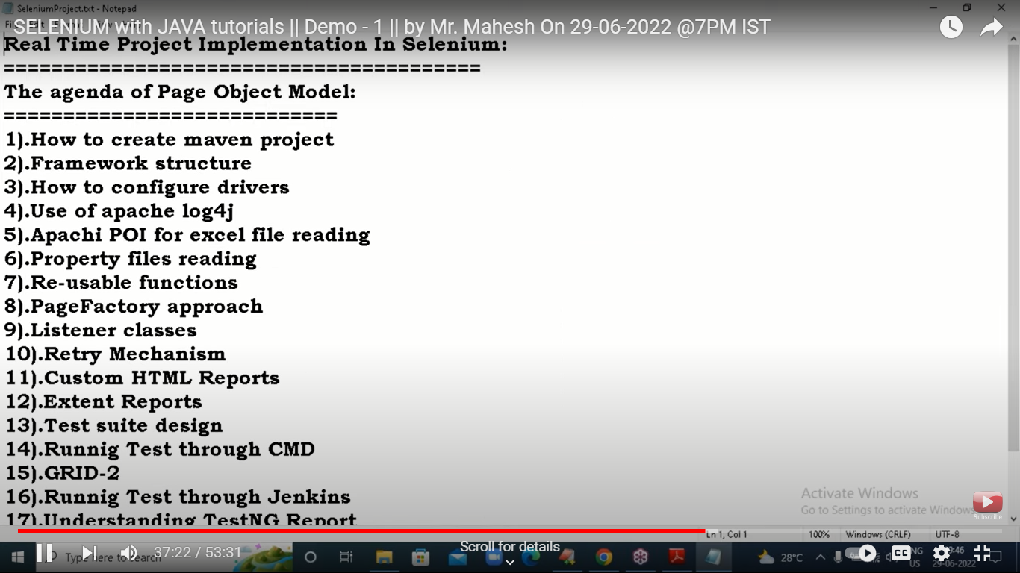

18. GIT Hub

